
SRM Institute of Science and Technology
SET D
College of Engineering and Technology
School of Computing
SRM Nagar, Kattankulathur – 603203, Chengalpattu District, Tamilnadu
Academic Year: 2022-23 (EVEN)
Test: CLA-T1 Date: 10.02.2023
Course Code & Title: 18CSC205J - Operating Systems Duration: 50 Minutes
Year & Sem: II Year / IV Sem Max. Marks: 25

Course Articulation Matrix: (to be placed)
S.No | Course Outcome | PO1 | PO2 | PO3 | PO4 | PO5 | PO6 | PO7 | PO8 | PO9 | PO10 | PO11 | PO12 | PSO1 | PSO2 | PSO3
1 | CO1 | 3 |  | 3 |  |  |  |  |  |  |  |  |  | 2
2 | CO2 | 2 | 1 | 3 |  |  |  |  |  |  |  |  |  |  | 2
3 | CO3 | 3 | 2 | 2 |  |  |  |  |  |  |  |  |  | 2
4 | CO4 | 3 | 2 | 2 |  |  |  |  |  |  |  |  |  |  | 2
5 | CO5 | 3 |  | 2 | 2 |  |  |  |  |  |  |  |  | 2

Part - A
(10 X 1 = 10 Marks)
Instructions: Answer all
Q. No | Question | Mark | BL | CO | PO | PI Code
 | Which system call returns the process identifier of a terminated child?  A. Wait  B. Exit  C. Fork  D. Get  Answer: A. Wait | 1 | 1 | 1 | 1 | 1.6.1
 | In a time-sharing operating system, when the time slot given to a process is completed, the process goes from the running state to the __________  A. Blocked state  B. Ready state  C. Suspended state  D. Terminated state  Ans: B. Ready State | 1 | 2 | 1 | 1 | 1.6.1
 | A long-term scheduler is __________________  - Selects which process has to be brought into the ready queue  - Selects which process has to be executed next and allocates CPU  - Selects which process to remove from memory by swapping  - None of the mentioned  Ans: A It selects which process has to be brought into the ready queue | 1 | 2 | 1 | 1 | 1.6.1
 | What is the output of the following program?  main( )  {  int a = 10;  if ((fork ( ) == 0))  a++;  printf (“%d\n”, a );  }  - 10 and 11  - 10  - 11  - 11 and 11  Ans: A | 1 | 3 | 1 | 3 | 3.7.1
 | - ----------- section of code cannot be executed parallel by the processes  - Entry section  - Critical section  - Exit section  - Reminder section  Ans: B Critical Section | 1 | 1 | 1 | 1 | 1.6.1
PART B – 10 Marks
Answer any Two Questions
 | Describe different function / services provided by the operating system in detail.  Memory Management:  - This refers to management of the main or primary memory.  - Main memory is a quick storage area that may be accessed directly by the CPU.  - To execute a program, it has to be present in the main memory. After execution the memory region is released to use by other programs. Therefore, there can be more than one program present at a time. Hence, it is required to manage the memory.  - Functions of OS in Memory management:  Allocates and deallocates the memory. Keeps a record of which part of primary memory is used by whom and how much. Distributes the memory while multiprocessing. In multiprogramming, the operating system selects which processes acquire memory when and how much memory they get.  Process Management  Every software that runs on a computer, whether in the background or in the frontend, is a process. A Program in execution is called as process. Multiple process will be waiting in a queue to get the processor for processing. OS is the decision maker which decides the order of process for processing. The process management unit executes different CPU scheduling algorithms to determine the order of the process for execution. It also determines the amount of processing time allocated to each When more than one process runs on the system . Allocates and deallocates processor to the processes.  It also tracks the status of these processes to understand if they succeed or fail. Since every device should get a chance to use the processor. Hence, the OS makes sure that the devices get fair processor time.  It the efficiency of the system.  File Management  Data is stored on files. OS helps to create, edit, update and delete files. It helps in transferring files from one device to another. It specifies which process receives the file and for how long. It also keeps track of information, location, uses, status, and so on.  The operating system is also responsible for organizing the files on the disk.  Allocates and deallocates resources. Decides who gets the resources.  I/O Management  Any kind of Input, we want to give to the computer goes through the operating system. Any output that we get is also acted upon by the Operating System. This management involves coordinating various input and output devices  Ex:  When the user instructs the system to play abc.mp3 on his computer using a music application. Here, the OS will first read the audio file from his hard disk (which is the storage device from where the Input is retrieved) and then send the player output to the speakers (output device) where it will be played.  Device Management  It helps the computer to communicate with peripheral devices via their respective drivers. An operating system regulates device connection using drivers. The processes may require devices for their use. This management is done by the OS.  Functions of Device management in OS  Allocating and deallocating devices to different processes. Keeps records of all the devices attached to the computer. Decides which device to be allocated to which process and for how much time. | 10 | 1 | 1 | 1 | 1.6.1
 | Assume that you are trying to download a large 2-GB file from the Internet. The file is available from a set of mirror servers, each of which can deliver a subset of the file's bytes; assume that a given request specifies the starting and ending bytes of the file. Explain how you might use threads to improve the download time. Also implement same.( Hint: No.of mirror servers can be assumed as 5 and use Pthread in c)  Ans:  The client process can create separate threads. Each thread can fetch a different part of the file from one of the mirror servers. This can help reduce downtime. This is a single link shared by all threads. This link can become a bottle neck as the number of threads becomes very large.  Implementation:  FILE *data_fp ;  static int block_size ;  main() {  data_fp = fopen(...) ;  int filesize = ftell(fp) ;  block_size = filesize/6 ;  for (int i=0 ; i<N_THREADS ; i++ ) {  start_offset = filefize*((float i)/N_THREADS) ;  pthread_create(search_start, ... , &start_offset) ;  }  }  search_start(void *arg) {  // Extract the offset to start  long start_offset = * (long *) arg ;  // Create separate FILE*, with separate position, buffers, etc.  FILE *local_fp = fdopen(fileno(data_fp), "r") ;  // Position at the thread specific offset  fseek(local_fp, start_offset, SEEK_SET) ;  char buff[256] ; // max line size  // Loop until EOF, some exit condition, or block_size characters processed  for (long p = 0 ; p < block_size && fgets(buff, sizeof(buff), local_fp) ; p += strlen(buff)) {  // Compare, check, whatever is needed  ...  if (need_to_stop) break ;  } ;  fclose(local_fp) ;  } | 10 | 4 | 1 | 3 | 3.8.2
 | - Discuss the actions taken by a kernel to context-switch between processes.  Actions taken by a kernel to context-switch between processes are -  - The OS must save the PC and user stack pointer of the currently executing process, in response to a clock interrupt and transfers control to the kernel clock interrupt handler  - Saving the rest of the registers, as well as other machine state, such as the state of the floating point registers, in the process PCB is done by the clock interrupt handler.  - The scheduler to determine the next process to execute is invoked the OS.  - Then the state of the next process from its PCB is retrieved by OS and restores the registers. The restore operation takes the processor back to the state in which the previous process was previously interrupted, executing in user code with user-mode privileges.  - Explain the life cycle of a process with the help of process state transition diagram.  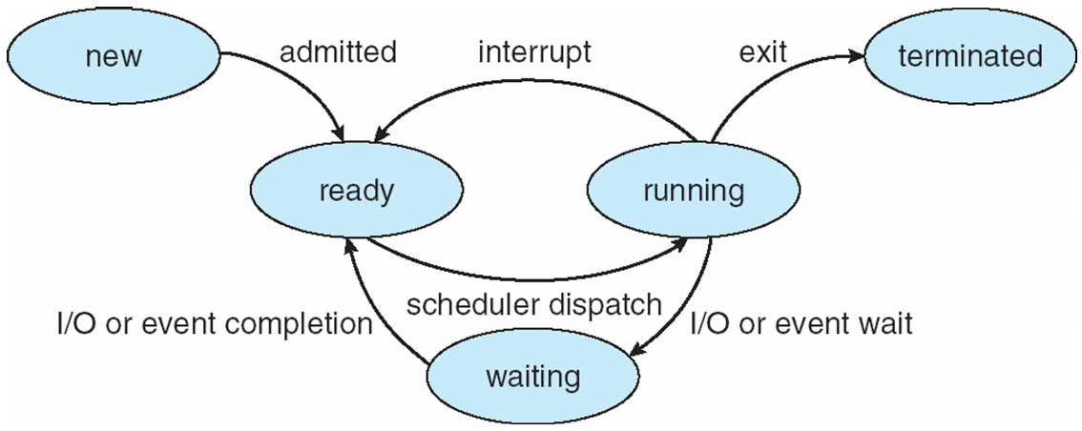  Process State summary  - New – New Process Created  - Ready – Process Ready for Processor/computing power allocation  - Running – Process getting executing  - Wait – Process waiting for signal  - Terminated – Process execution completed | 5  5 | 2  2 | 1  1 | 1  1 | 1.7.1  1.6.1

